To Run, SW5.2 needs to be on. To flash, it needs to be off.

In IAR, make sure a .mot file is being created:

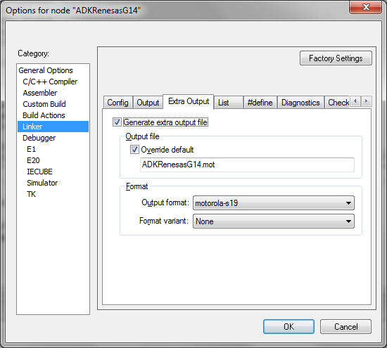

The flashing tool is obtained from Renesas:

<http://www2.renesas.eu/products/micro/download/index.html/file/download/id/396/package/5299>

You are looking for the RFP Renesas Flash Programmer free version.

Setup of this tool is as follows:

Invoke the programmer and select the dev kit at shown:

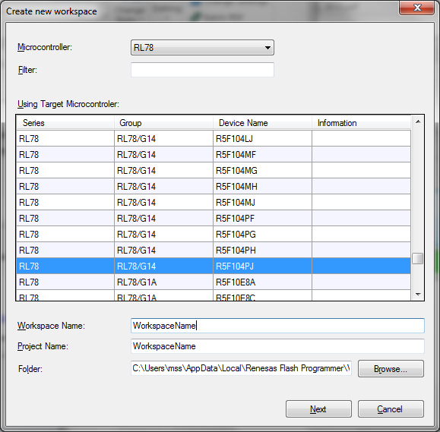

The device needs to be plugged it and should appear as a COM port (COM14 in this case)

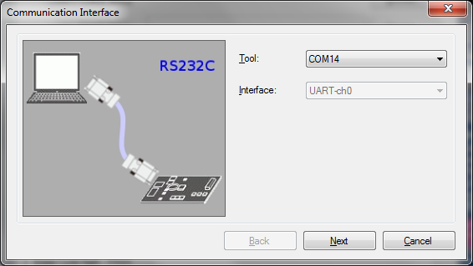

Defaults for this screen:

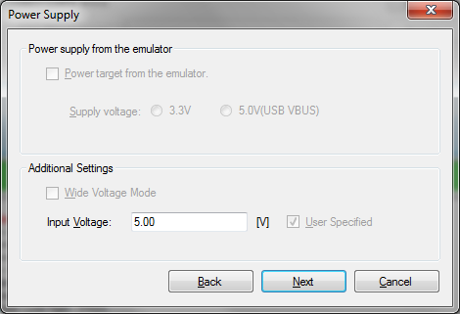

Click complete.

Then click browse and select the .mot file in the IAR project, which for my project is in: YRDKRL78G14\Debug\Exe\ADKRenesasG14.mot

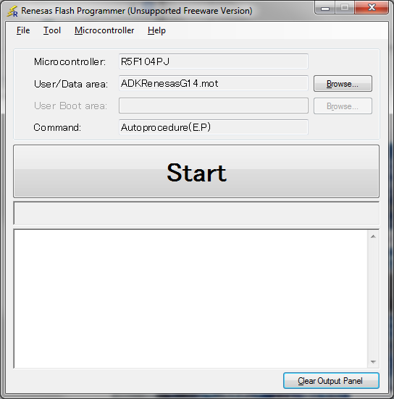

Make sure SW4.2 is OFF

Hit start.

Unplug, turn SW5.2 ON

Plugin and program will run.